EXPERIMENT 10: Create a simple cloud software application for online super market using any Cloud Service Provider to demonstrate SaaS with the template of customer name, address, phone, email, items, quantity etc. with the item classification form.

Step 1: - Go to ZOHO.com

Step 2: - Create and account and log into the account

Step 3: - Create an application

Step 4: - Create login page

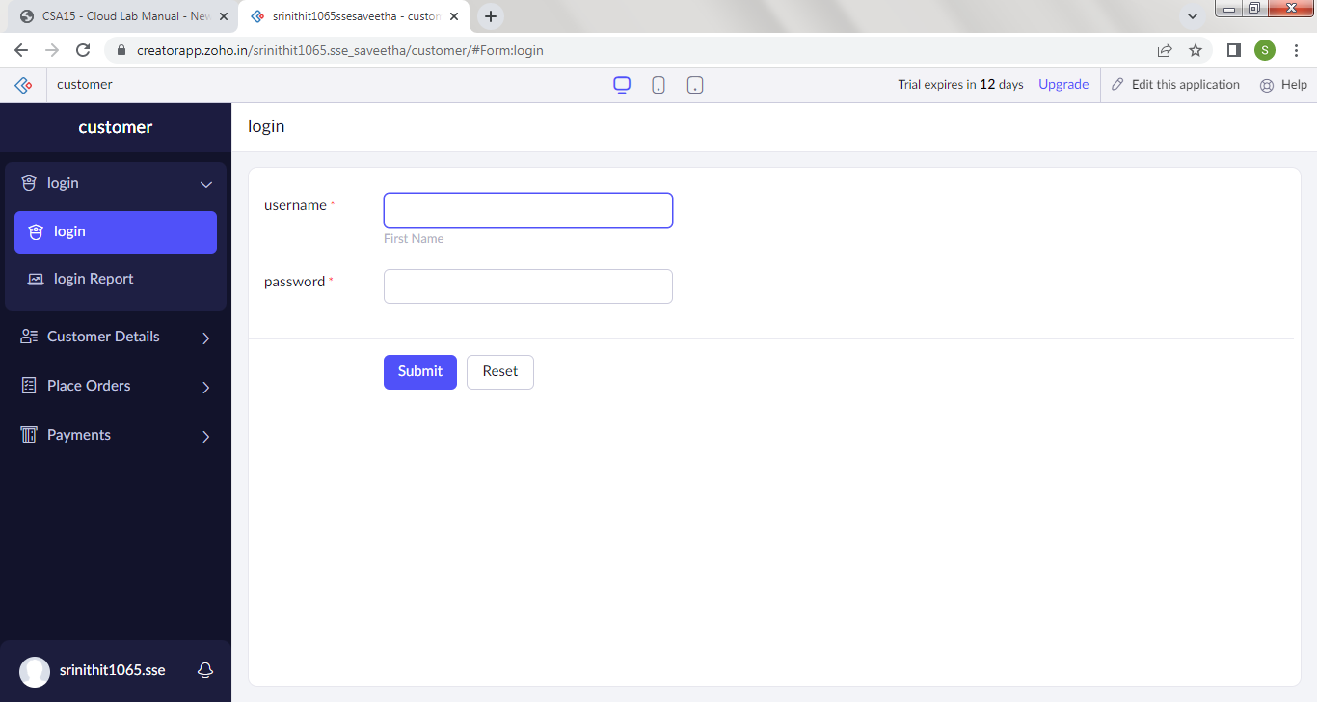

Step 5: - Create a form for customer details

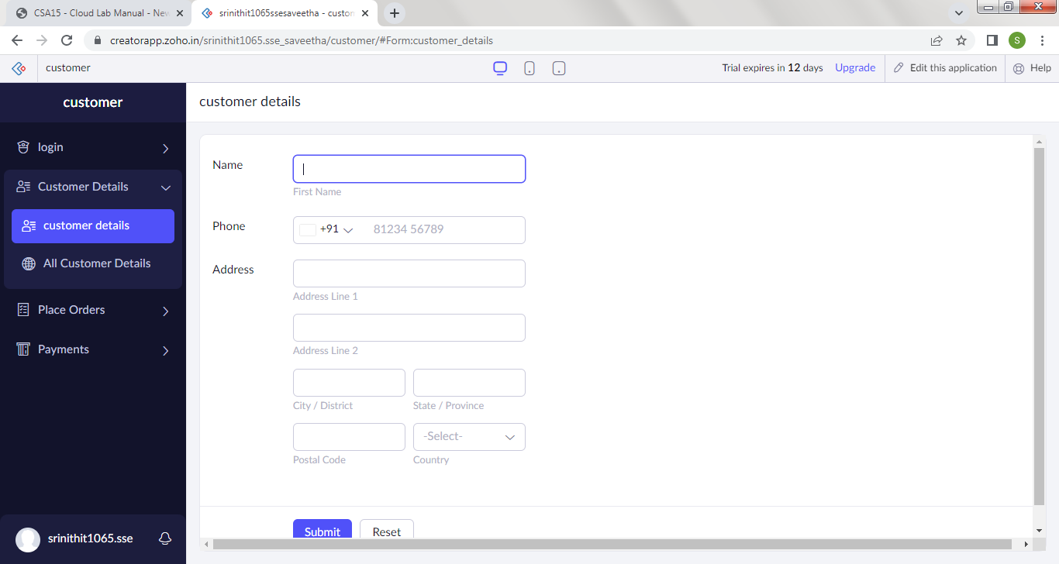

Step 6: - Create a form for product list

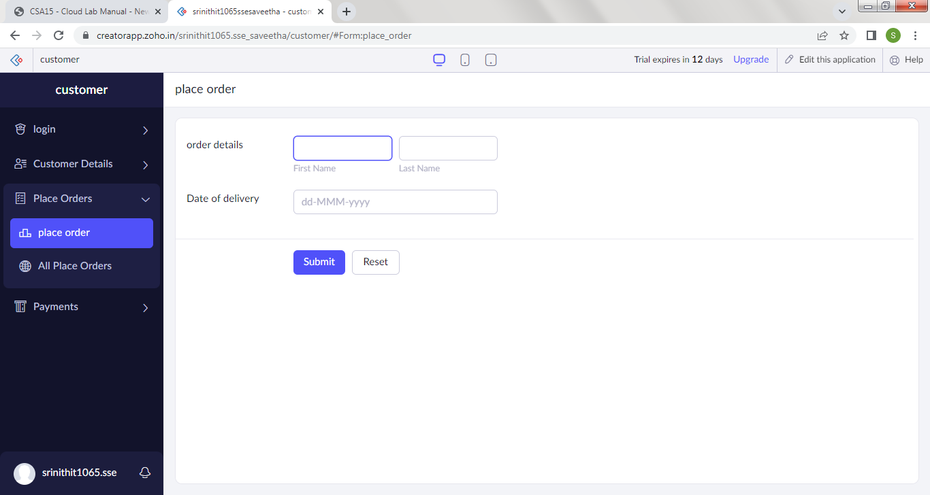

Step 7: - Create a form payment

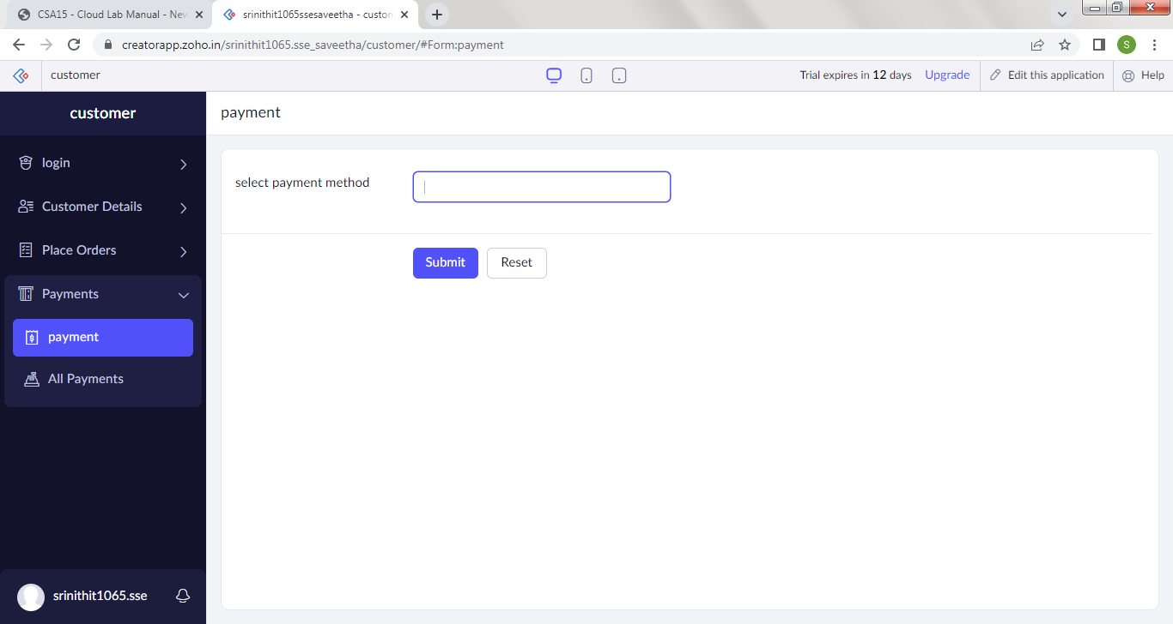

Step 8: - Click on the Access development live to view the output

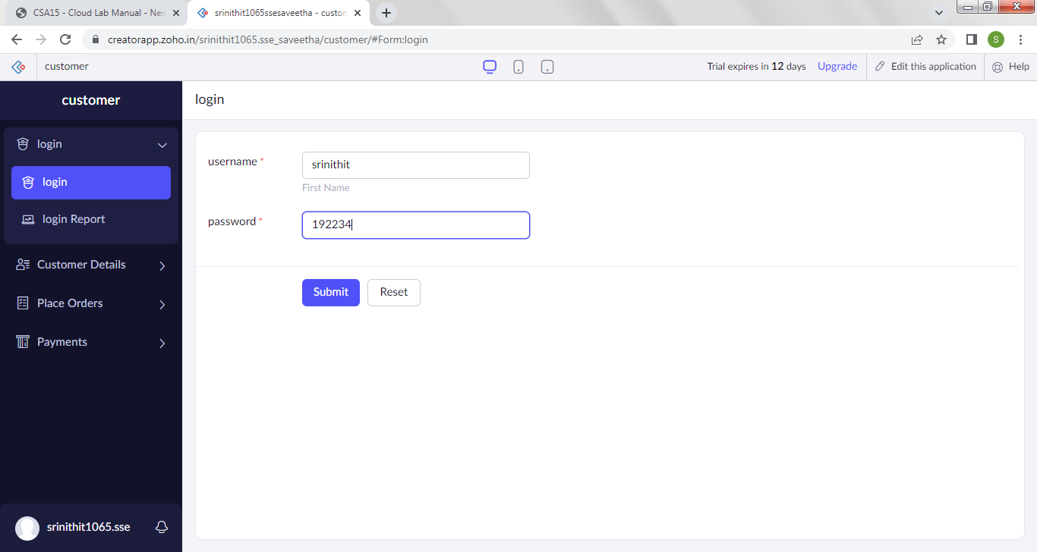

Step 9: - Click on the report to see the saved data’s

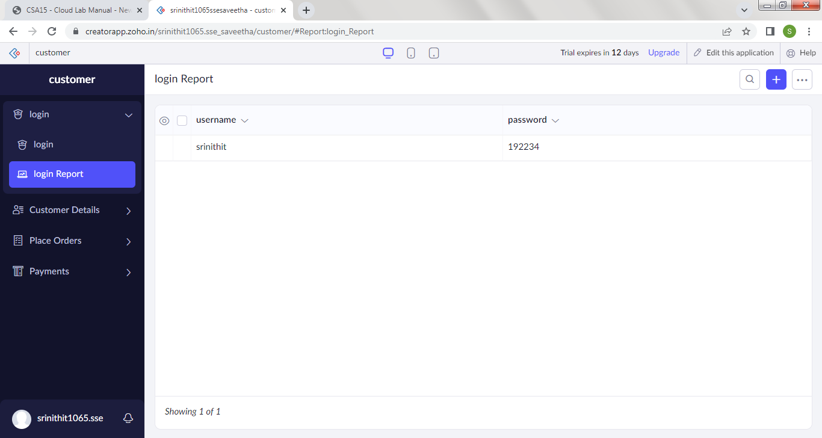

Step 10: - Click on the mobile icon to view the output in mobile format

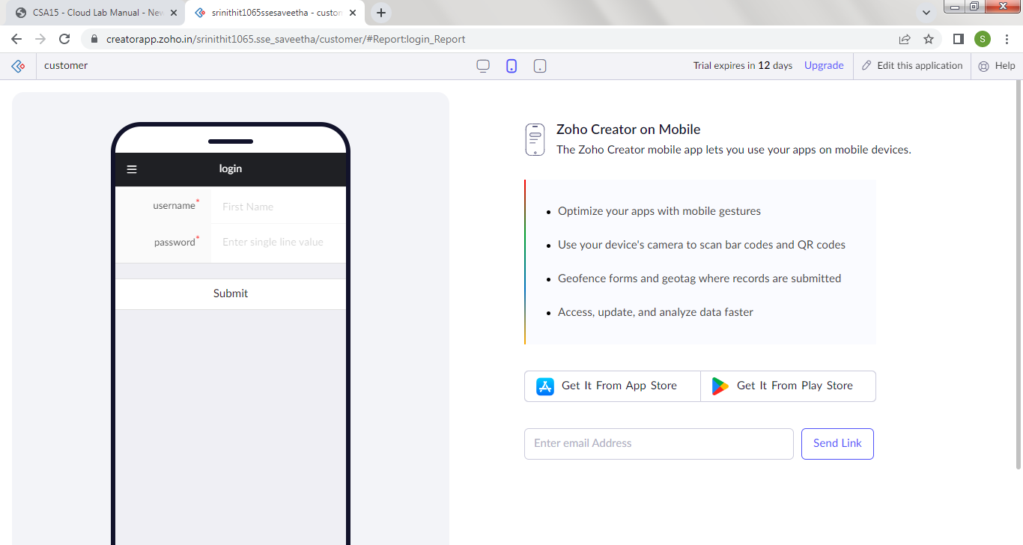

Step 11: - Click on the tablet icon to view the output in tablet format

